
Electric Stairway
Model Kensington
Design Chart

Units C & D
Ford Lane Industrial Estate
Ford, Arundel
West Sussex, BN18 0DF
Tel: 01243 785246
Fax: 01243 790996
Email: sales@loftcentre.co.uk
Website: www.loftcentre.co.uk
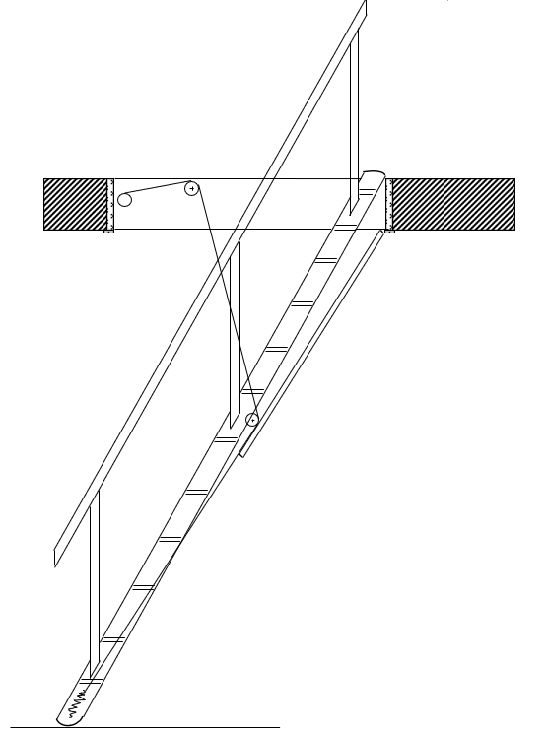

D

C2

 | Details | (mm)
A | Opening Length
B | Opening Width
C1 | Ceiling Height
C2 | Floor to Floor Height
D | Floor Thickness
E1 | Storage Height
E2 | Storage Length
F | Available Going

C1

F

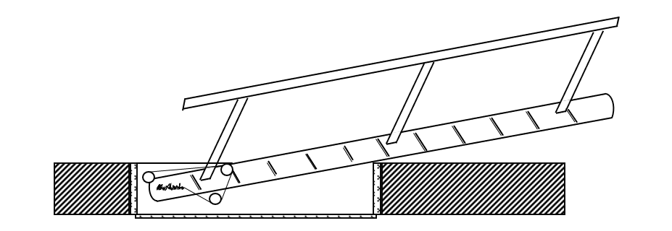
E2

E1

Angle Preference (47/50/52/55/57): | °

Please tick option below

Handrail Choice:

Basic Handrail (3 Uprights & top Rail) to one side

Basic Handrail (3 Uprights & top Rail) to both sides

Newel Posts & Balustrading to one side

Newel Posts & Balustrading to both sides

Name:

Address:

Email:

Tel No:

Notes

